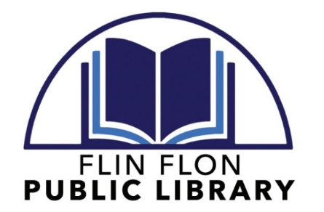

Minutes of the
Flin Flon Library Board of Directors
February 18, 2022 MEETING Minutes
Via Zoom

A regular meeting of the Flin Flon Library Board was held on February 18, 2022 at 12:00 p.m.

QUORUM

Quorum was declared present based on the attendance of the following Board Members:
- Bill Hanson, Chairperson
- Tim Spencer, Secretary/Treasurer
- Kathryn Drapak
- Val Dixon
- Judy Pettersen
- Becky Hyska

Board Members absent:
- Tim Babcock
- Melody Borschewski (Alternate)

Staff present:
- Lisa Slugoski, Library Administrator

PROCEEDINGS

- Chair Hanson called the meeting to order at 12:12 p.m.

- Acceptance of the agenda
MOTION: To accept the agenda as presented (Pettersen); seconded (Dixon); passed unanimously

- Acceptance of the previous meeting minutes
MOTION: To accept the December 18, 2021 meeting minutes as presented (Spencer); seconded (Hyska); passed unanimously

CORRESPONDENCE

- Letter dated December 10, 2021 from the Kimberley Foundation (re: Pat Morris Community Matter Grant Application – Conclusion Letter)
- Letter dated December 10, 2021 from the Pas Regional Library (re: Shared Funding Cheques for the community of Cranberry Portage)
- Letter dated December 23, 2021 from Kendall & Pandya (re: letter confirming independence, as required by Canadian Auditing Standards)
- Contract for Audit dated December 23, 2021 from Kendall & Pandya (re: scope and nature of the audit to commence for the 2021 fiscal year)
- Undated letter from 102.9 CFAR (re: renewal of annual radio promotions including pricing)
- Letter dated January 17, 2022 from Manitoba Minister of Sport, Culture and Heritage (re: 2022 deadlines for grant application, approved budget and 2021 statistics)
- Letter insert from Manitoba Hydro (re: Electricity Rate Increases on January 1, 2022)
- Letter from Women’s Safe Haven & Resource Services Inc. (re: REDress Project)
- Letter dated February 2, 2022 from Hope North Suicide Prevention Committee Member (re: What Keeps You Well Week, February 20-26)

OLD BUSINESS
- Review of Finalized 2022 Budget
Slugoski presented the finalized 2022 budget. Hanson noted acceptance of the budget into the record was not required at this time.

NEW BUSINESS
- Review of the following Board Seats:
-Chairperson
-Vice-Chairperson
-City of Flin Flon Representative
-Town of Creighton Representative
-Village of Denare Beach Representative
-Member-at-Large
-Member-at-Large (Alternate)
All board seats were held for another term, with the exception of Babcock and Borschewski. Replacement members to be found before our next meeting.
2. Wage Discussion (re: Hiring a permanent Library Clerk)
After discussion, it was agreed that Slugoski would offer a permanent position to the
Youth Library Clerk upon the expiration of grant hours for the youth position, at the
same hours and wage from the grant term.

REPORTS

- Library Administrator’s Report (Slugoski)
Slugoski presented the Administrator’s Report.

NEXT MEETING(S)

- April 2022 (Exact date TBD)
ADJOURNMENT
The meeting adjourned at 1:10 pm.
Minutes submitted by Lisa Slugoski, Library Administrator

